**Snake game using Python**

**UNIVERSITY OF ENGINEERING**

**&**

**MANAGEMENT, JAIPUR**

**Snake game using Python**

Submitted in the partial fulfillment of the degree of

**BACHELOR OF TECHNOLOGY**

in

**COMPUTER SCIENCE & ENGINEERING**

under

**Meghnad Saha Institute of Technology**

BY

Soumajit Chatterjee

University Roll no: 14200119002

**ACKNOWLEDGEMENT**

The endless thanks goes to Lord Almighty for all the blessings he has showered onto me, which has enabled me to write this line note in my research work. During the period of my research, as in the rest of my life, I have been blessed by Almighty with some extraordinary people who have spun a web of support around us. Words can never be enough in expressing how grateful I am to those incredible people in my life who made this thesis possible. I would like an attempt to thank them for making my time during my research in the Institute a period I will treasure. I am deeply indebted to my research supervisor, Prof. Krishnendu Kundu for guiding me such an interesting these topic. Each meeting with him added in valuable aspects to the implementation and broadened my perspective. She has guided me with his invaluable suggestions, lightened up the way in my darkest times and encouraged me a lot in the academic life.

Fulera Kazi

**ABSTRACT**

**This project in python language of Snake game** is a simple Graphical User Interface application with very simple graphics. This game is fun to play and any one can play the game. In this project, you can play the popular “snake Game” just like you played it elsewhere. You have to use the up, down, right or left arrows to move the snake. Apples are provided at the several co-ordinates of the screen for the snake to eat. Every time the snake eats the food, its length will by increased by one element along with the score.It isn’t the world’s greatest game, but it does give you an idea of what you can achieve with a relatively simple python program and perhaps the basis by which to extend the principles and create more interesting games of your own. The game called “Snake Game” typically involve the player controlling a snake, there is no official version of the game, so gameplay varies. The most common version of the game involves the snake eating apple which make it longer, with the objective being to avoid running into a border or the snake itself for as long as possible.

**Table of Contents**

Table of Contents...............................................................................................1

1. INTRODUCTION...................................................................................2
2. ABOUT PYTHON………………………………………………………3
3. PROPOSED MODEL……………………………………………………4
4. RESULTS & DISCUSSION...................................................................5
5. CONCLUSION.......................................................................................8
6. BIBLIOGRAPHY...................................................................................9

1

INTRODUCTION

This project gives a summary to our work for the game. It will increase our knowledge. This game is fun to play and anyone can play the game. The game called “Snake Game” typically involve the player controlling a snake, there is no official version of the game, so gameplay varies. The most common version of the game involves the snake eating apple which make it longer, with the objective being to avoid running into a border or the snake itself for as long as possible. The player loses when the snake either runs into a border or its own body . Because of this, the game becomes more difficult as it goes on, due to the growth of the snake. Nokia has installed the “Snake Game” on many of its phones. The game is also available on several websites, including YouTube, which allows viewers to play the game while a video loads.

2

ABOUT PYTHON

**Python** is an interpreted high-level general-purpose programming language. Python's design philosophy emphasizes code readability with its notable use of significant indentation.. Its language constructs as well as its object-oriented approach aim to help programmers  write clear, logical code for small and large-scale projects.

Python is dynamically-typed and garbage-collected. It supports multiple programming paradigms including structured (particularly, procedural), object-oriented and functional programming. Python is often described as a "batteries included" language due to its comprehensive standard library.

3

PROPOSED MODEL

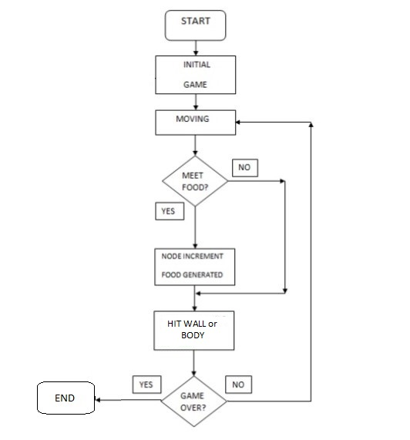

4

RESULT & DISCUSSION

1. Create the Front page of the game

* First Input your details in the given data.
* Start the game

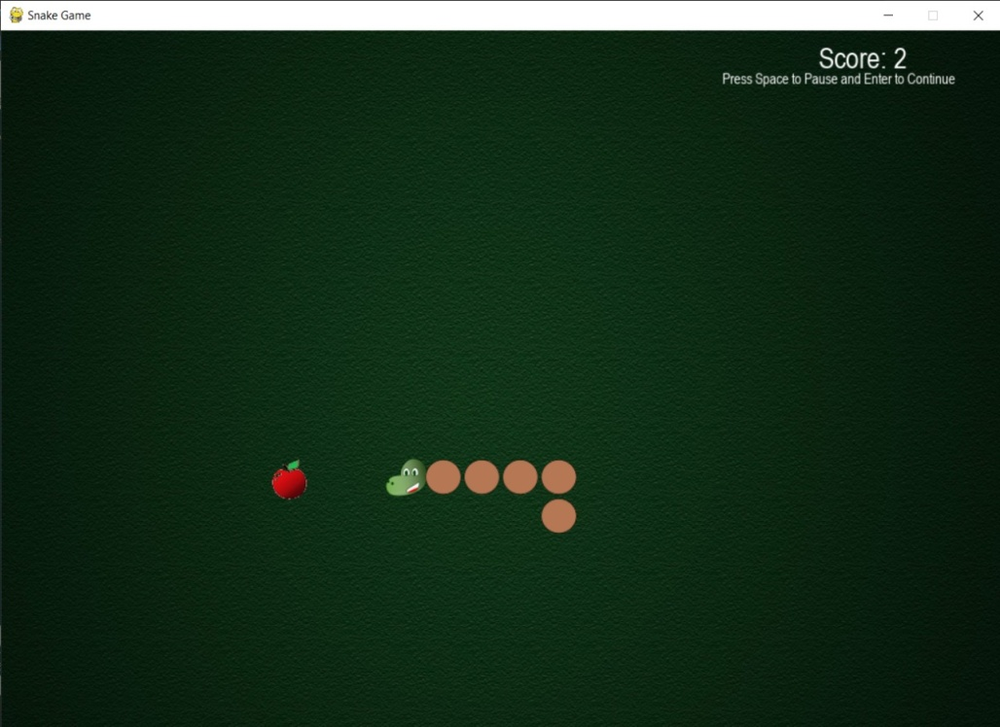

5

1. Starting the game

* Snake is moving and hits the boundary

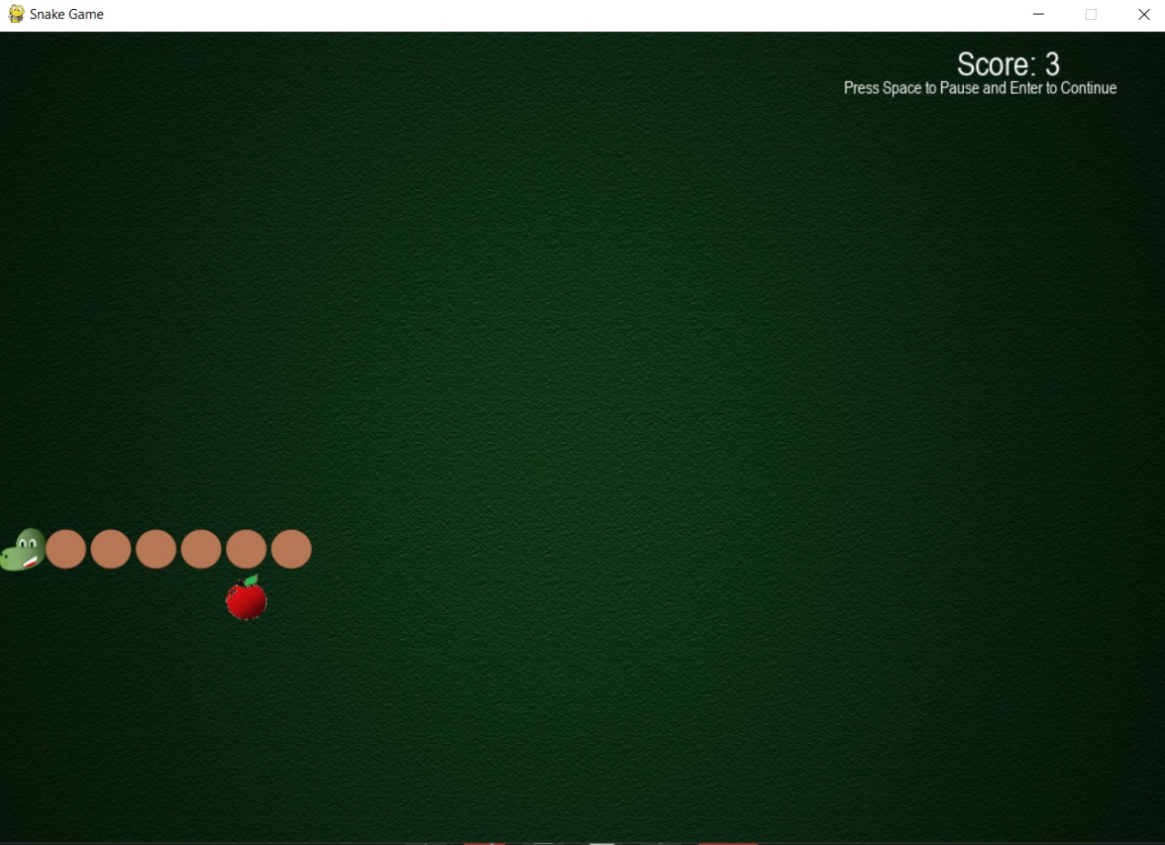

6

1. Snake hits its own body

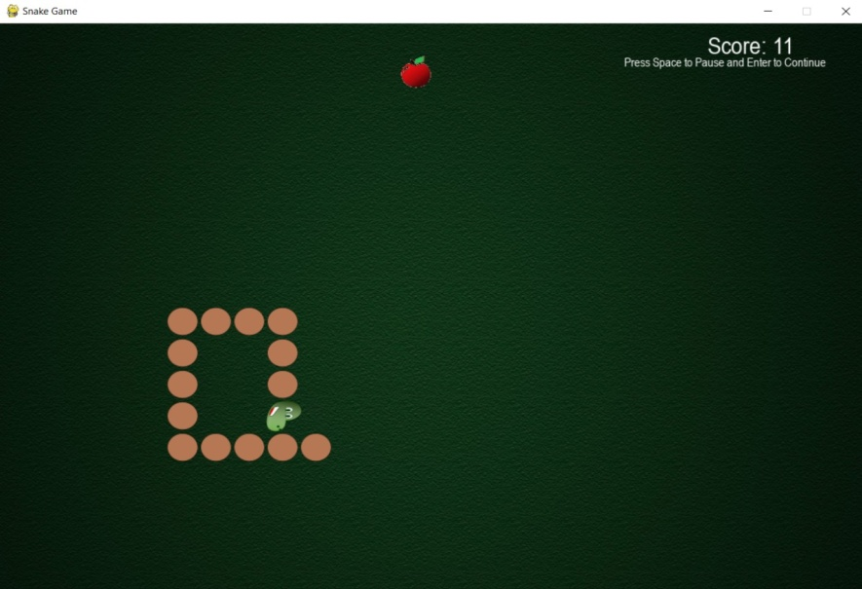

1. Game is over and you can view the high score

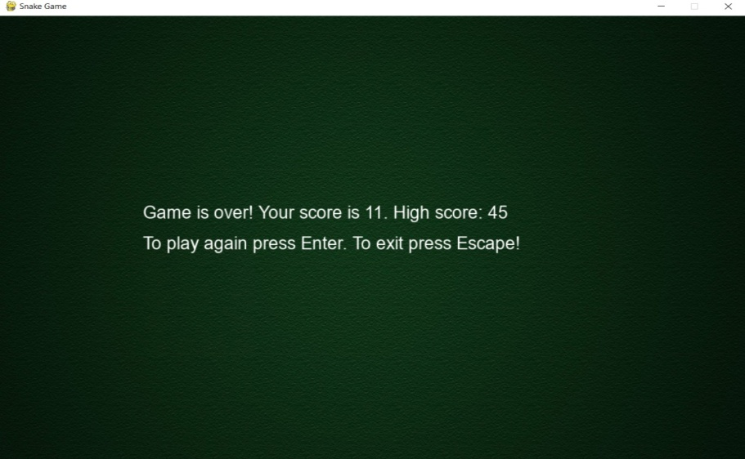

7

CONCLUSION

We were successful in creating a single player version of snake game. Our project will be able to implement in future after making some changes and modifications as we make our project at a very low level.

Added to this my term and paper contain the basic description to create a snake game, how the view the high score and exit from the file python program. This term paper is the outcome of my hard and laborious work and contain a complete knowledge on the path independent line integral.

Here, i want to end my lines with the hope my term paper will be equally appreciated and heartly accepted by all. Also, all my faults and mistake would be forgiven. We request ever one to take the game positively.

8

BIBLIOGRAPHY

* <https://www.python.org/>
* <https://www.pygame.org/docs/>
* <https://www.mathsisfun.com/games/snake.html>
* <https://snake.googlemaps.com/>
* <google.com>
* <youtube.com>

9